eProject: Cera Ceramics

Cera Ceramics

*User Guide*

|  |  |  |
| --- | --- | --- |
| Supervisor | Miss Ramsha | |
| Batch | 2408G1 | |
| Group | 02 | |
| Serial Number | **Enrollment Number** | **Student name** |
| 1 |  | SAIM ANSARI |
| 2 |  | HASSAN RAZA |
| 3 |  | ALI ABBAS |
| 4 |  | UBAIDULLAH |

**Aptech**

North Nazimabad Center 2

AGGREGATED SITEMAP

Cera Ceramics English

(1.index.html)

Cera Ceramics

(0.welcome.html)

Email us page

(email.html)

.

Cera ceramics English

(1.index.html)

Special Tiles

Sub Dropdown

Floor Tiles

Sub Dropdown

Wall Tiles

Sub Dropdown

Comparison page

(06. compare.html)

Contact us page

(07contact.html)

News & Updates page

(05. news.html)

Experts page

(4.Expert.html)

Categories

(03. Dropdown)

About us page

(2. about.html)

Home page

(1.Index.html)

Bathroom wall tile

(bathroomwalls.html)

.

Cool Roof Tiles

(coolroof.html)

.

Anti Static Tiles

(antistatic.html)

.

Tac Tiles

(bedroomfloor.html)

.

Germ free Tile

(germfree.html)

.

Commercial space Floor tiles

(commercialfloor.html)

.

Living Floor tiles

(livingfloor.html)

.

Outdoor Floor tiles

(bedroomfloor.html)

.

Kitchen Floor tiles

(outdoorfloor.html)

.

Bathroom Floor tiles

(bathroomfloor.html)

.

Bedroom Floor tile

(bedroomfloor.html)

.

Commercial space wall tiles

(commercialwall.html)

.

Living wall tiles

(livingwall.html)

.

Bedroom wall tiles

(bedroomwalll.html)

.

Outdoor wall tiles

(outdoorwall.html)

.

Kitchen wall tiles

(kitchenwalls.html)

.

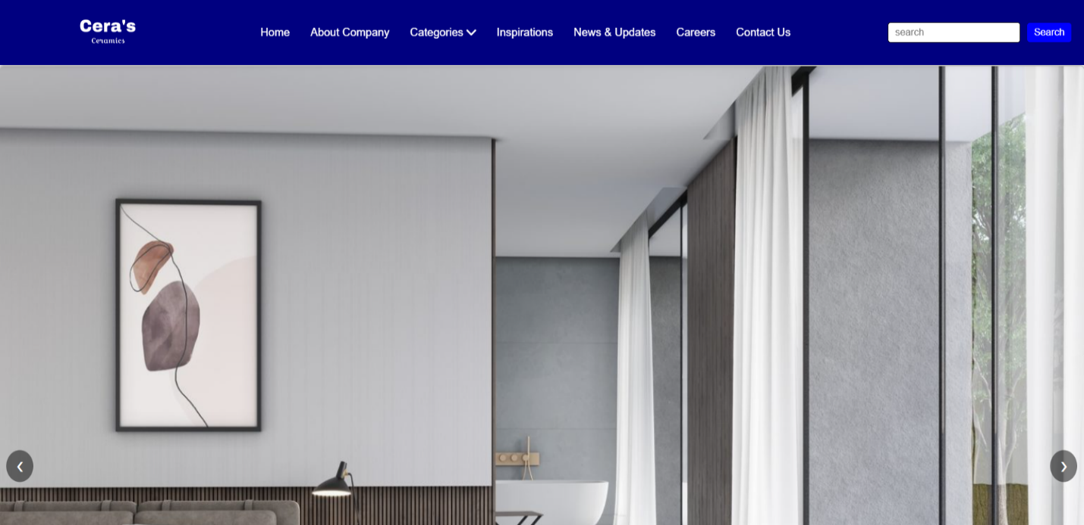 Figure 1: Upper Frame interface

01 Layout Top

* Home page. (1.index.html)
* About Company. (2.about.html)
* Categories. (3.DropDown)
* Line up 01 .Wall Tiles.
* Bathroom Wall Tiles. (bathroomwalls.html)
* Kitchen Wall Tiles. (kitchenwalls.html)
* Outdoor Wall Tiles. (outdoorwall.html)
* Bedroom Wall Tiles. (bedroomwall.html)
* Living Wall Tiles. (livingwall.html)
* Commercial space Wall Tiles. (commercialwall.html)
* Line up 02. Floor Tiles.
* Bedroom Floor Tiles. (bedroomfloor.html)
* Bathroom Floor Tiles. (bathroomfloor.html)
* Kitchen Floor Tiles. (kitchenfloor.html)
* Outdoor Floor Tiles. (outdoorfloor.html)
* Living Floor Tiles. (livingfloor.html)
* Commercial space Floor Tiles. (commercialwall.html)
* Line up 03. Special Tiles.
* Germ free Tiles. (germfree.html)
* Tac Tiles. (tac.html)
* Anti Static Tiles. (antistatic.html)
* Cool Roof Tiles. (coolroof.html)
* Experts. (04.Expertcorner.html)
* News & Updates. (05.news.html)
* Comparison. (06.compare.html)
* Contact us. (07.contacttest.html)

Drop-down menu bar. The product tab of the **Menu** can be removed and contains submenus that lead to subpages. You can be access these pages (main page or subpage) by clicking on its tab.

Figure 2: 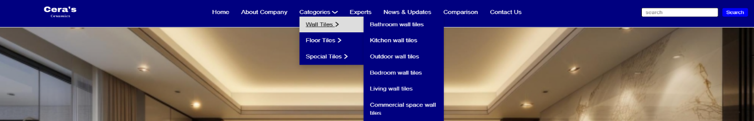Drop Down menu

02 Layout Bottom



Figure 3: Bottom Frame interface

Display Information Such as menu, company name, address, contact, details, and email. There are **quick links** to different section like bedroom, kitchen, and terrace. A **news latter** subscription form is also present, along with a copy right logo.

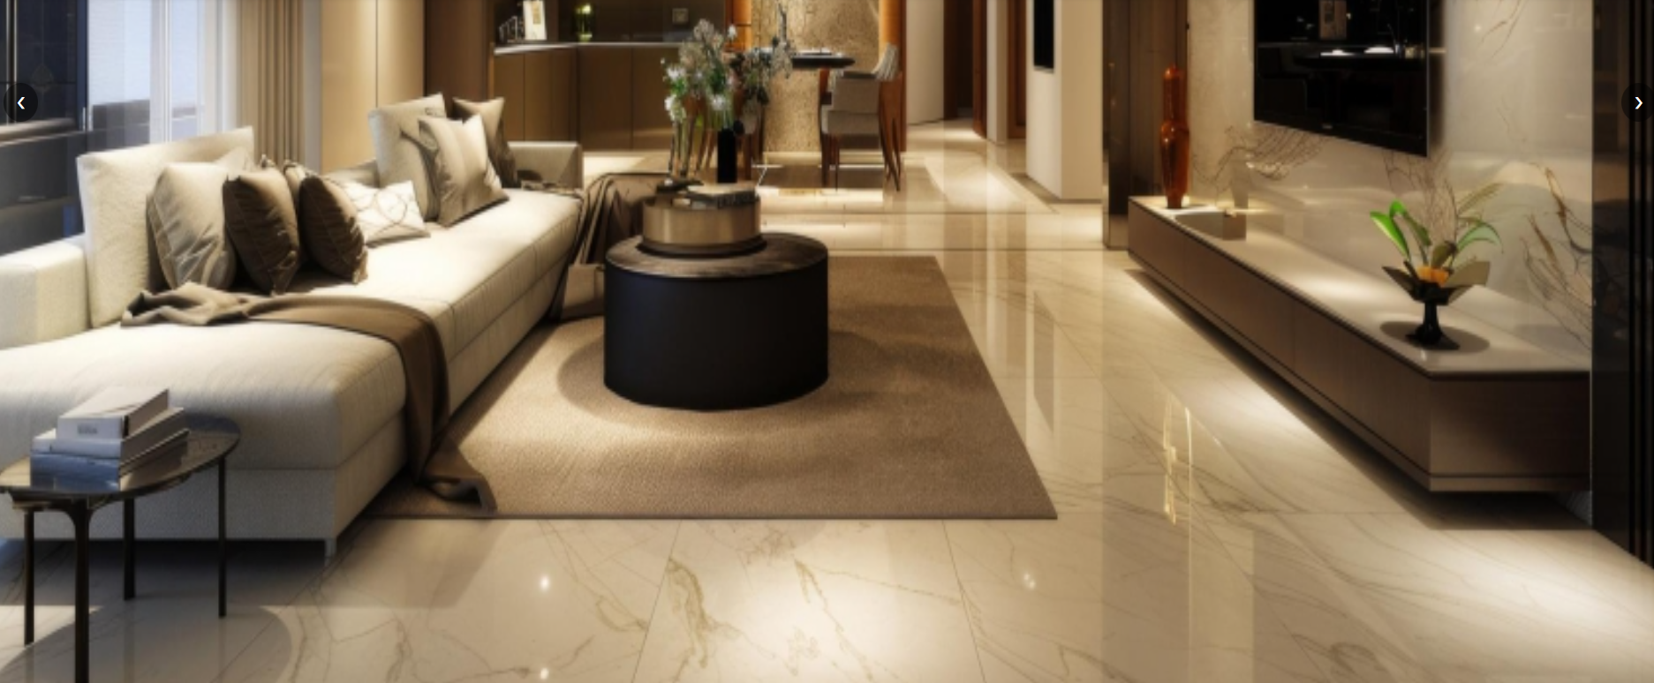

03. Home Page. (index.html)

Figure 4: Home page middle

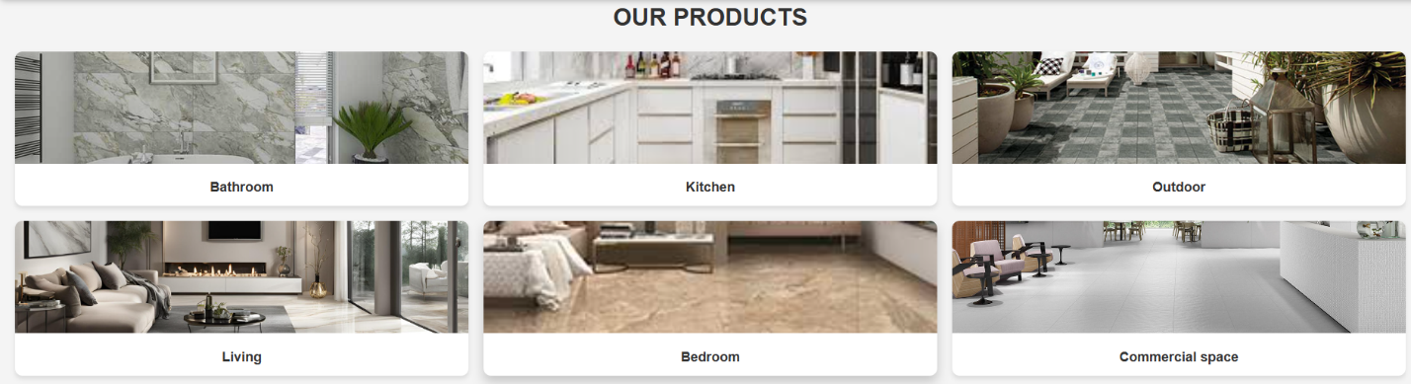 Figure 5: Home page middle 

The interface of the home page is shown as: **Our products** and features different categories of ceramics or tile related products. The categories include **bathroom**, **kitchen**, **outdoor**, **living**, **bedroom**, and **commercial space,**

Each represented by a high-quality.

04. About us. (about.html)

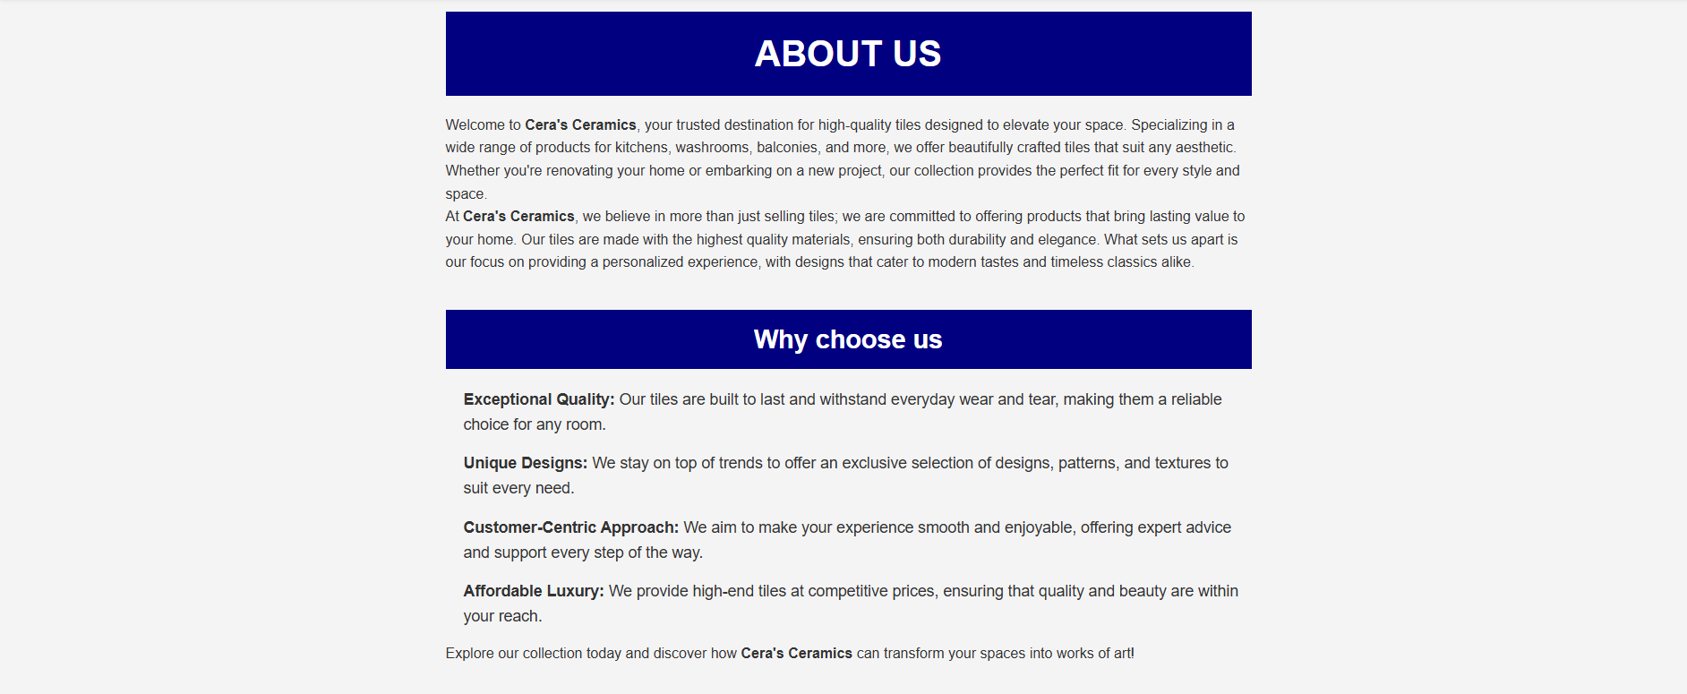

Figure 6: About us Page

This is the **About Us** page, where **Cera's Ceramics** is introduced. It highlights the company's **quality, unique designs, customer service, and affordability**. This page informs users that our tiles are **durable, stylish, and reliable**.

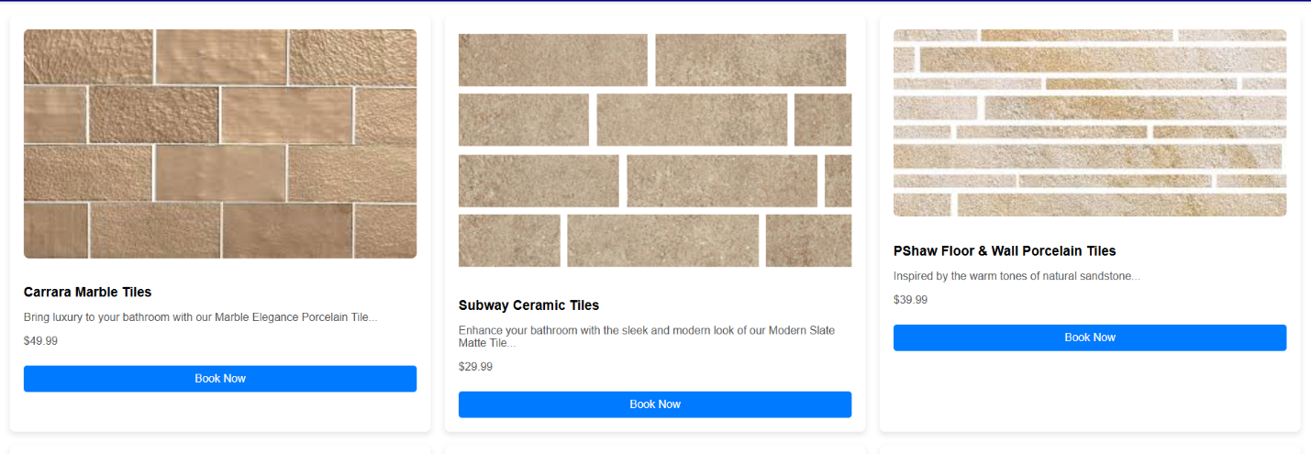

05. Categories. (Dropdown)

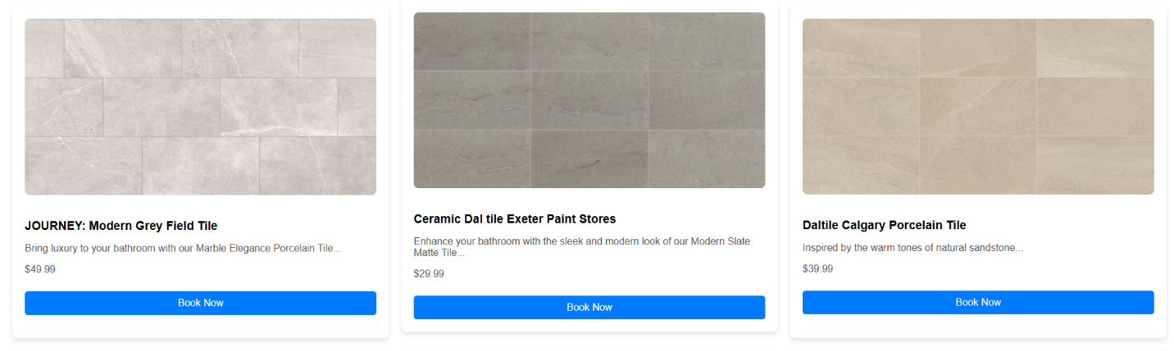 Figure 7: Product page (Wall Tiles)

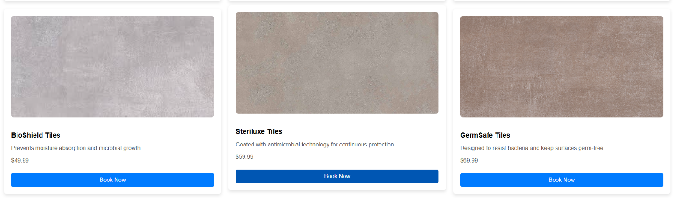 Figure 8: Product page (Floor Tiles)

Figure 9: Product page (Special Tiles)

The interface of the product page is shown as Figure: product page, when user click on product, the product details will appear.

But the page details product lines

* Home page. (1.index.html)
* About Company. (2.about.html)
* Categories. (3.DropDown)
* Line up 01 .Wall Tiles.
* Bathroom Wall Tiles. (bathroomwalls.html)
* Kitchen Wall Tiles. (kitchenwalls.html)
* Outdoor Wall Tiles. (outdoorwall.html)
* Bedroom Wall Tiles. (bedroomwall.html)
* Living Wall Tiles. (livingwall.html)
* Commercial space Wall Tiles. (commercialwall.html)
* Line up 02. Floor Tiles.
* Bedroom Floor Tiles. (bedroomfloor.html)
* Bathroom Floor Tiles. (bathroomfloor.html)
* Kitchen Floor Tiles. (kitchenfloor.html)
* Outdoor Floor Tiles. (outdoorfloor.html)
* Living Floor Tiles. (livingfloor.html)
* Commercial space Floor Tiles. (commercialwall.html)
* Line up 03. Special Tiles.
* Germ free Tiles. (germfree.html)
* Tac Tiles. (tac.html)
* Anti Static Tiles. (antistatic.html)
* Cool Roof Tiles. (coolroof.html)

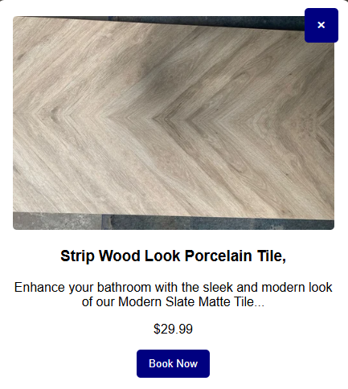

Figure 10: Product Details and Book now

After viewing the product details, when the user clicks on "Book Now," they will be redirected to a new window where the booking details will be displayed.

Figure 11: Booking Page 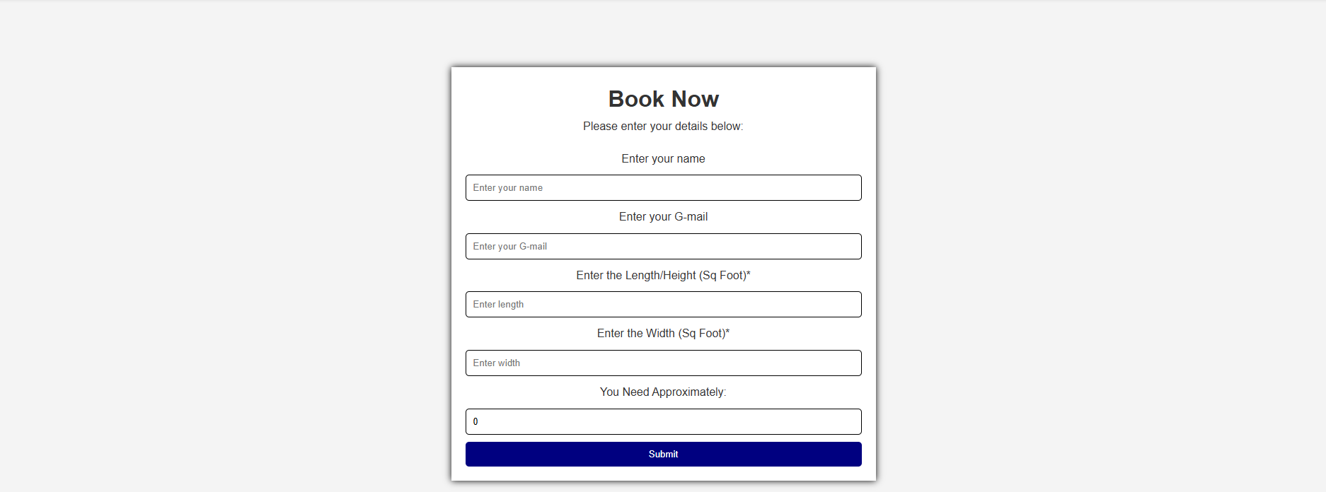

* **Name** – Enter your name.
* Don’t leave blank.
* Don’t included number, punctuation, hyphens, or any special characters.
* Limited to 5 to 10 latter characters.
* **Gmail** – Enter your email address (Gmail).
* Start write a letter or numbers.
* End with a letter and number.
* Dots, hyphens, and under scores are allowed email names but must comply with the following requirements.
* Don’t use in the start and end position.
* Its previous and next position must be alphanumeric character.
* The previous and next position immediately after the @ character followed by one or more phrases that start with dot and followed by a string of up to 4 latter characters.
* **Length/Height (Sq Foot)**
* Enter the required length/height in square feet.
* **Width (Sq Foot)** –
* Enter the required width in square feet.
* **Approximate Requirement**
* This may be auto-calculated by the system or manually entered by the user.
* **Submit Button**
* To submit the form.

When the information in each case is valid, clicking the submit button

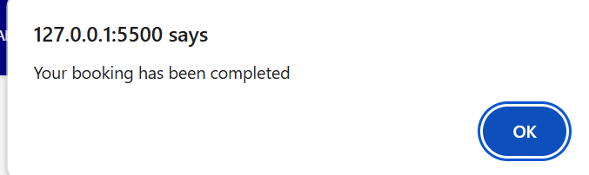 Figure 12: Pop up, Your booking has been completed

06. Experts. (Expertcorner.html)

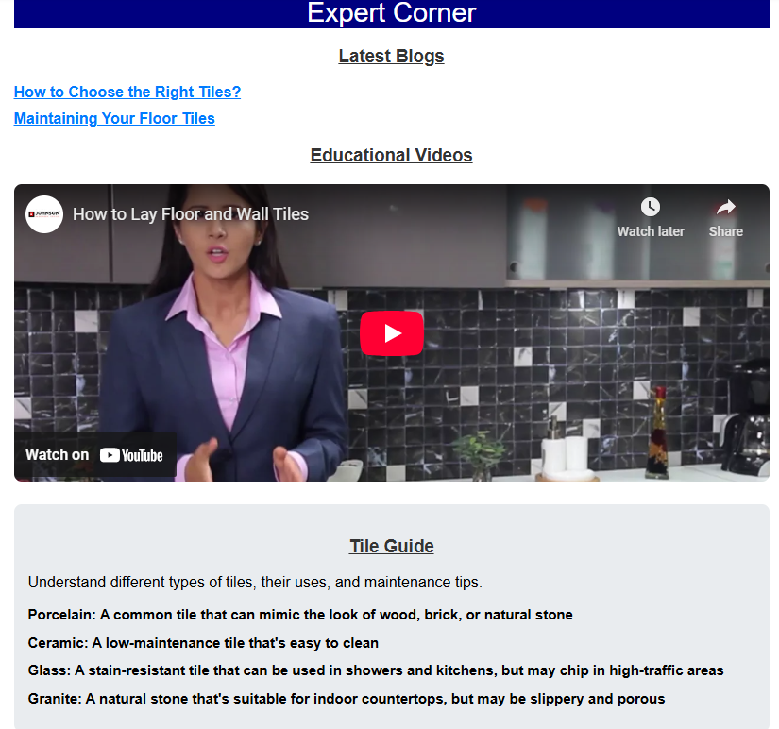

Figure 12: Our Experts Advisor

On this page, our experts have shared their opinions on how to lay tiles, how to choose the right tiles, and the differences between porcelain, ceramic, glass, and granite tiles. A **Tile Calculator** is also added to help users estimate the number of tiles needed.

Links to articles on:

* How to choose the right tiles. (blog1.html)

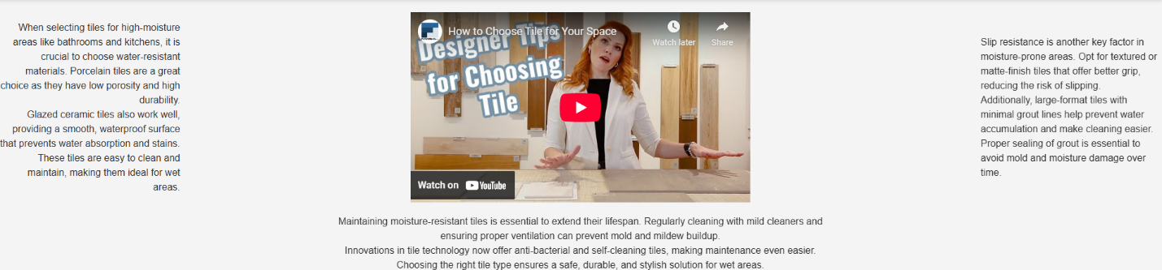

Figure 13: how to choose the right tiles.

* How to maintain floor tiles. (blog2.html)

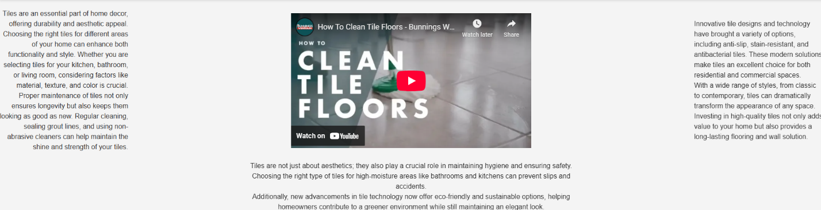

Figure 14: how to clean and maintain floor tiles

Figure 15: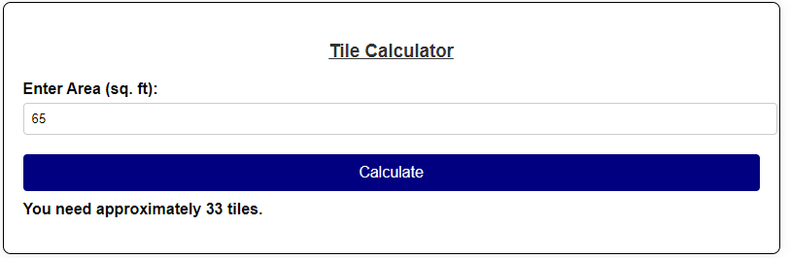 Tile calculator

The user will enter their requirement by specifying the size of their house in square feet. After clicking the **Calculate** button, the calculator will determine the number of tiles needed based on their requirements.

07. Comparison. (compare.html)

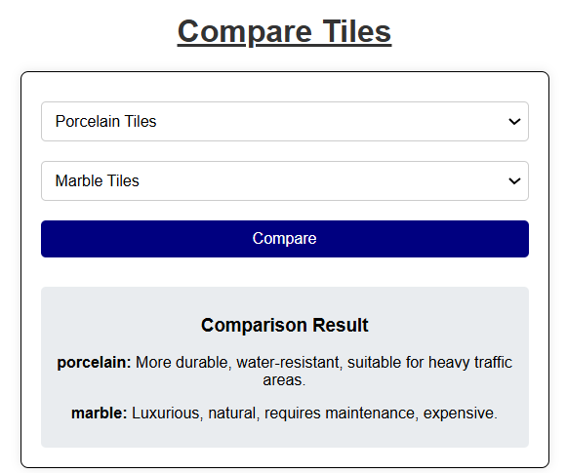

Figure 15: Tile Comparison page

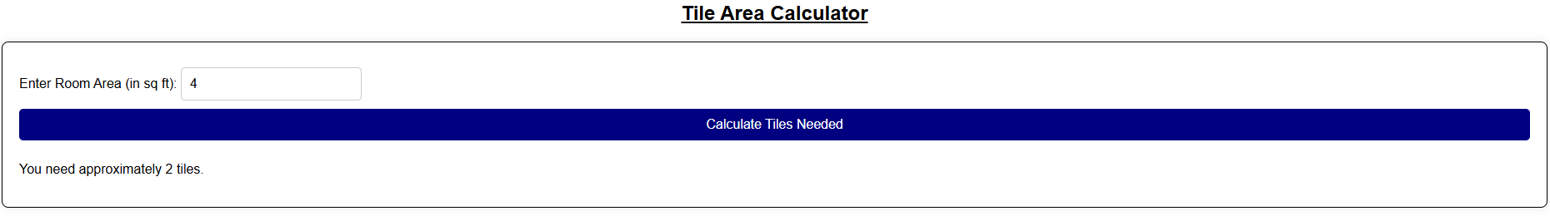We have created a **comparison frame** to compare tiles, where the differences between tiles are displayed. The user selects tiles for comparison and clicks the **Compare** button, which then shows a comparison between the two selected tiles.

Figure 16: Tile Area Calculator

The user will enter the room size in square feet based on their requirements and click the **Calculate Tile Needed** button. The calculator will then provide the required number of tiles.

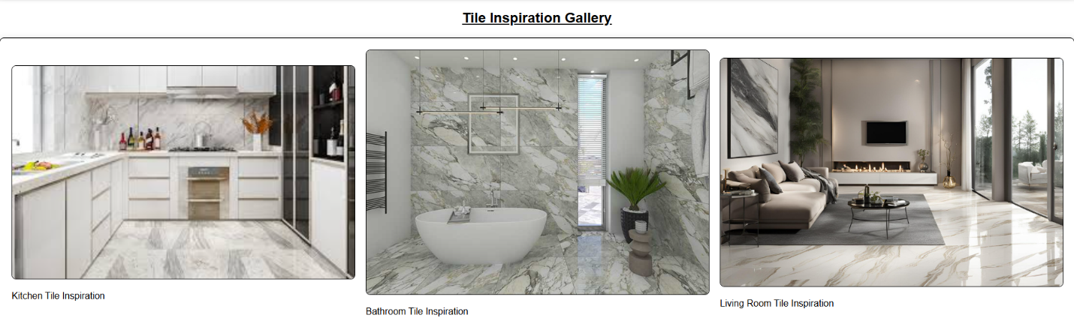

Figure 17: Tile Inspiration Gallery

08. Contact us. (contact.html)

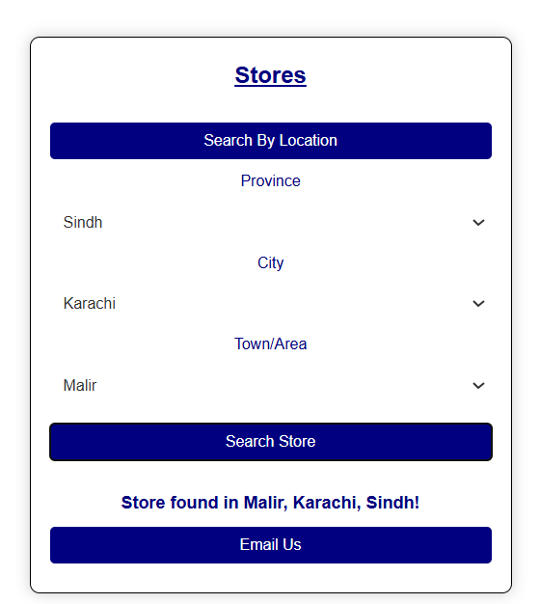

Figure 18: Contact and Store Locator page

* **Select Your Location:**
* Choose your **Province** (e.g., ).
* Select your **City** (e.g.,).
* Pick the **Town/Area** (e.g.,).
* **Find the Store:**
* Click the **Search Store** button.
* If a store is available in the selected area, it will be displayed (as shown in the image: *"Store found in Malir, Karachi, Sindh!"*).
* **Contact the Store:**
* Click the **Email Us** button.
* A new window will open where the user can enter their details to contact the store.

For store location, the user needs to enter their **province**, after which the cities of that province will automatically appear. The user will then select their **city**, followed by the **area**, and click the **Search Store** button. If a store is available in that area, it will be displayed.



Figure 19: Email Button to contact us

After finding a store, when the user clicks on the email, a new window will open where they need to enter all email details. This will allow us to contact the user.

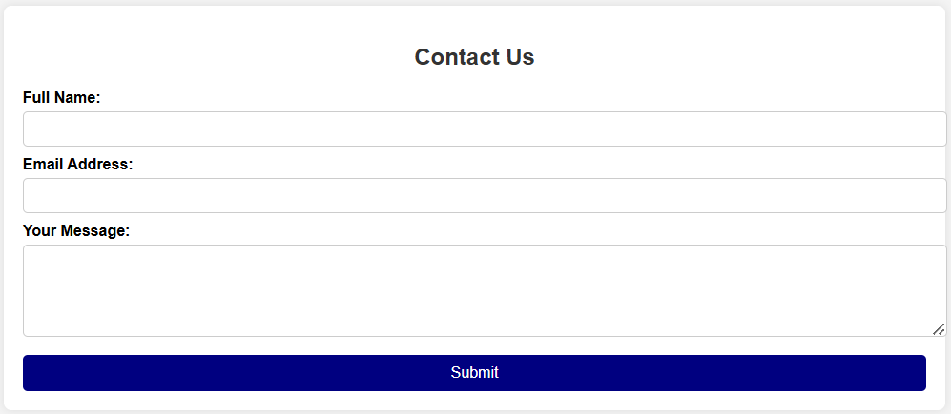

Figure 20: Contact us

While filling out the contact form, the **first name is mandatory**. After that, the user must enter their **email address**. Then, using the **message box**, the user can provide their **requirements or queries**.

Once everything is filled out, clicking the **Submit** button will display a message below:  
**"Your email has been submitted."**

1. **Full Name:**
   * The user must enter their **complete name** in the first field.
   * Don’t leave blank.
   * Don’t included number, punctuation, hyphens, or any special characters.
   * Limited to 5 to 10 latter characters
2. **Email Address:**
   * The user needs to provide their **email address** for communication.

* Start write a letter or numbers.
* End with a letter and number.
* Dots, hyphens, and under scores are allowed email names but must comply with the following requirements.
* Don’t use in the start and end position.
* Its previous and next position must be alphanumeric character.
* The previous and next position immediately after the @ character followed by one or more phrases that start with dot and followed by a string of up to 4 latter characters.

1. **Your Message:**
   * The user can type their **query, request, or message** in this text box.
2. **Submit Button:**
   * After filling out the details, the user clicks the **Submit** button to send the message.

**Purpose:**

This form allows users to **contact the company/store** directly for inquiries, support, or other concerns.

Thank you for reading the documentation

Please follow the instruction above